
Waste Management Driver

Salary: £31,022 up to £32,061 per annum pro rata including market supplement
Grade: 4
Location: Hinckley, Leicestershire
Contract: Permanent, 37 hours per week, working Monday to Friday

About the role
We currently have a vacancy for Category C driving position within our Waste Management team.
We are very proud of our in-house waste collection services and have just invested in a new fleet of refuse collection vehicles, with new food waste collection vehicles recently arriving

What you will be doing
As the Waste Management Driver, you will be responsible for a small team collecting waste across our waste streams, such as food waste, refuse, dry recycling or garden waste, as part of the wider waste management services we provide.

About you
As the team leader, you will ensure tasks and paperwork are completed in a professional manner, that excellent customer service is provided to our residents and help ensure better management of our resources. You will also be supporting residents to recycle their waste effectively, enabling the council to meet Corporate Plan objectives.

Essential criteria
- You must hold a minimum of Category C licence.
- Be physically fit, able to walk long distances each day and move wheeled bins, sacks and any other waste containers.
- Be committed individuals who are looking to provide high quality public services to our residents.

Find out more
For an informal discussion about this exciting opportunity please call Barry Upton, Waste Management Team Leader on 01455 255778
Apply with your CV and supporting statement via our online application form at https://jobsandcareers.hinckley-bosworth.gov.uk/ or for an application pack call 01455 255836 quoting position reference: C840

Closing date: 5 June 2026
Interview date: 10 and 11 June 2026
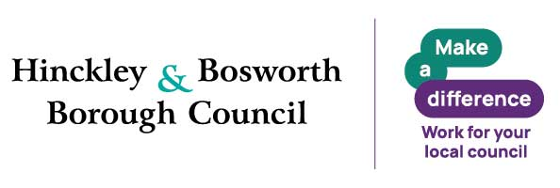
Why Join Hinckley & Bosworth Borough Council
A great place to work, grow and make a real difference. Join a flexible, supportive council offering great development, strong wellbeing, financial benefits and values that put people first.
Make a real difference in Hinckley & Bosworth.
Benefits
- Flexible working – flexi‑time, hybrid, part‑time and compressed hours (role‑dependent)
- Generous annual leave – 26–33 days + bank holidays
- Career development – training, funded qualifications, apprenticeships, e‑learning
- Strong wellbeing support – EAP & counselling, occupational health, wellbeing sessions
- Financial benefits – competitive pay, cost‑of‑living increases, local government pension scheme
- Salary‑sacrifice schemes – tusker cars, tech, cycle to work
- Relocation package up to £5,000
- Lifestyle discounts – retail, travel, entertainment and more

Values and behaviours

We are energetic and passionate, proud of and dedicated to our area.

We strive for excellence. We learn, innovate, challenge, seek out opportunities and embrace new ideas.

We trust, respect and are honest. We listen to each other, to our communities and to our partners and work with them supportively to get things done.

We put the needs of our customers first. We care about being the best we can be and take responsibility for our actions.
Inclusive Employer
We are a Disability Confident and Care Leaver Friendly Employer. Guaranteed interviews are offered to eligible applicants who meet the essential criteria. Reasonable adjustments are available throughout the recruitment process.
Eligibility criteria applies

